Assignment 5

1. First Come First Serve (FCFS) Scheduling

Definition:

First Come First Serve (FCFS) is the simplest CPU scheduling algorithm.
The process that arrives first in the queue gets executed first. It operates like a queue (FIFO - First In, First Out).

Working:

The CPU is allocated to the process that arrives first.

Once a process starts execution, it runs until completion (non-preemptive).

Advantages:

Simple and easy to implement.

Disadvantages:

Poor average waiting time when long processes arrive first.
Output:
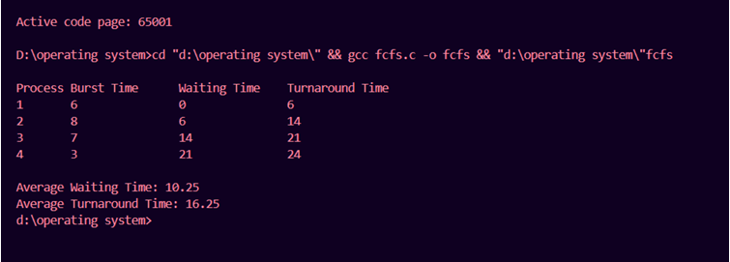

2. Shortest Job First (SJF) Scheduling

Definition:

Shortest Job First (SJF) selects the process with the smallest burst time and executes it first.
It can be preemptive (interruptible) or non-preemptive (runs till completion).

Working:

The process with the shortest execution time is selected first.

If two processes have the same burst time, FCFS (First Come First Serve) is used to break the tie.

Advantages:

Gives the lowest average waiting time.

Efficient CPU utilization.

Disadvantages:

Requires prior knowledge of burst times, which may not always be possible.

---

Code:

#include <stdio.h>

void findWaitingTime(int processes[], int n, int bt[], int wt[]) {
wt[0] = 0;

for (int i = 1; i < n; i++)
wt[i] = bt[i - 1] + wt[i - 1];
}

void findTurnAroundTime(int processes[], int n, int bt[], int wt[], int tat[]) {
for (int i = 0; i < n; i++)
tat[i] = bt[i] + wt[i];
}

void findAverageTime(int processes[], int n, int bt[]) {
int wt[n], tat[n];

findWaitingTime(processes, n, bt, wt);
findTurnAroundTime(processes, n, bt, wt, tat);

printf("Processes Burst Time Waiting Time Turnaround Time\n");

for (int i = 0; i < n; i++)
printf(" %d\t\t%d\t\t%d\t\t%d\n", processes[i], bt[i], wt[i], tat[i]);

float total_wt = 0, total_tat = 0;

for (int i = 0; i < n; i++) {
total_wt += wt[i];
total_tat += tat[i];
}

printf("\nAverage waiting time = %.2f", total_wt / n);
printf("\nAverage turnaround time = %.2f\n", total_tat / n);
}

void sortProcessesByBurstTime(int processes[], int bt[], int n) {
for (int i = 0; i < n - 1; i++) {
for (int j = i + 1; j < n; j++) {
if (bt[i] > bt[j]) {
int temp = bt[i];
bt[i] = bt[j];
bt[j] = temp;

temp = processes[i];
processes[i] = processes[j];
processes[j] = temp;
}
}
}
}

int main() {
int processes[] = {1, 2, 3};
int n = sizeof(processes) / sizeof(processes[0]);
int burst_time[] = {6, 8, 7};

sortProcessesByBurstTime(processes, burst_time, n);
findAverageTime(processes, n, burst_time);

return 0;
}
Output:
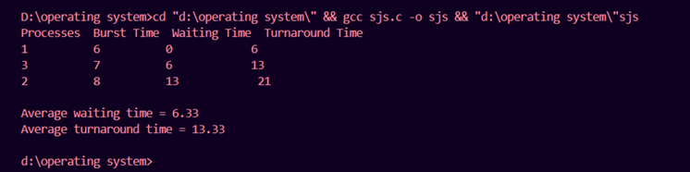

3. Round Robin (RR) Scheduling

Definition:

Round Robin (RR) scheduling assigns a fixed time quantum (time slice) to each process in a cyclic order.
If a process is not finished within its time slice, it is preempted and sent to the end of the queue.

Working:

A fixed time slice (quantum) is assigned.

Each process gets CPU time in a circular (round-robin) manner.

If a process doesn't complete within the quantum, it is preempted and moved to the end of the queue.

Advantages:

Ensures fairness as all processes get equal CPU time.

Avoids starvation because every process eventually gets executed.

Disadvantages:

High context switching overhead if the quantum is too small.

If the quantum is too large, it behaves like FCFS.

---

Code:

#include <stdio.h>

void findWaitingTime(int processes[], int n, int bt[], int wt[], int quantum) {
int rem_bt[n];

for (int i = 0; i < n; i++)
rem_bt[i] = bt[i];

int t = 0; // Current time

while (1) {
int done = 1;

for (int i = 0; i < n; i++) {
if (rem_bt[i] > 0) {
done = 0; // There is a pending process

if (rem_bt[i] > quantum) {
t += quantum;
rem_bt[i] -= quantum;
} else {
t += rem_bt[i];
wt[i] = t - bt[i];
rem_bt[i] = 0;
}
}
}

if (done)
break;
}
}

void findTurnAroundTime(int processes[], int n, int bt[], int wt[], int tat[]) {
for (int i = 0; i < n; i++)
tat[i] = bt[i] + wt[i];
}

void findAverageTime(int processes[], int n, int bt[], int quantum) {
int wt[n], tat[n];

findWaitingTime(processes, n, bt, wt, quantum);
findTurnAroundTime(processes, n, bt, wt, tat);

printf("Processes Burst Time Waiting Time Turnaround Time\n");

for (int i = 0; i < n; i++)
printf(" %d\t\t%d\t\t%d\t\t%d\n", processes[i], bt[i], wt[i], tat[i]);

float total_wt = 0, total_tat = 0;

for (int i = 0; i < n; i++) {
total_wt += wt[i];
total_tat += tat[i];
}

printf("\nAverage waiting time = %.2f", total_wt / n);
printf("\nAverage turnaround time = %.2f\n", total_tat / n);
}

int main() {
int processes[] = {1, 2, 3};
int n = sizeof(processes) / sizeof(processes[0]);
int burst_time[] = {24, 3, 3};
int quantum = 4;

findAverageTime(processes, n, burst_time, quantum);

return 0;
}
